QUANTUM MECHANICS

**QUANTUM TUNNELING**

ADITYA SINGH 2K19/EP/005

horizontal line

# 

# Introduction

Particles can, apparently, move through solid barriers! What is this quantum woo all about? This, we will find out by solving a standard textbook problem — that of a one-dimensional potential barrier. Our goal will be to derive the tunneling probability. We will then implement a simulation of a particle near such a potential barrier and look at the numerical solution of the problem.

Quantum mechanics differs from classical mechanics in the equation of motion and the required initial conditions.

# SCHR~~O~~DINGER’S EQUATION



A wave function that satisfies the nonrelativistic Schrödinger equation with V = 0. In other words, this corresponds to a particle traveling freely through empty space. The real part of the wave function is plotted.

### Time Dependent Equation

### The form of the Schrödinger equation depends on the physical situation (see below for special cases). The most general form is the time-dependent Schrödinger equation (TDSE), which gives a description of a system evolving with time:

To apply the Schrödinger equation, write down the Hamiltonian for the system, accounting for the kinetic and potential energies of the particles constituting the system, then insert it into the Schrödinger equation. The resulting partial differential equation is solved for the wave function, which contains information about the system.

### Time Independent Equation

### The time-dependent Schrödinger equation described above predicts that wave functions can form standing waves, called stationary states.

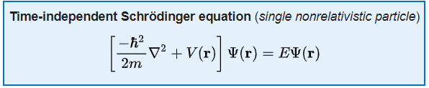

where the Hamiltonian *function* is the sum of the kinetic and potential energies. That is,

for a single particle in the non-relativistic limit.



Each of these three rows is a wave function which satisfies the time-dependent Schrödinger equation for a harmonic oscillator. Left: The real part (blue) and imaginary part (red) of the wave function. Right: The probability distribution of finding the particle with this wave function at a given position. The top two rows are examples of stationary states, which correspond to standing waves. The bottom row is an example of a state which is not a stationary state. The right column illustrates why stationary states are called "stationary".

# POTENTIAL BARRIER

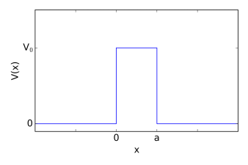

Consider a one-dimensional potential barrier described by a potential V(x):

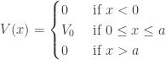

This naturally splits the physical system into three parts. Let us designate the solution for all x < 0 by \psi_{\text{I}}(x), for 0 \leq x \leq a  by \psi_{\text{II}}(x), and for all even greater x by \psi_{\text{III}}(x).

The time independent Schrödinger equation for the region \text{I} is:

-\frac{\hbar^2}{2m}\frac{\partial^2}{\partial x^2}\psi_{\text{I}}(x) = E \psi_{\text{I}}(x)

the solution of which is trivial. In the absence of a potential, the solution is a linear combination of sines and cosines. However, we might instead prefer the complex exponential form:

\psi_{\text{I}}(x) = A_r e^{ikx} + A_l e^{-ikx}

Plugging this into the left hand side of our equation of motion we find that:

-\frac{\hbar^2}{2m}\frac{\partial^2}{\partial x^2}\left( A_r e^{ikx} + A_l e^{-ikx} \right) = -\frac{\hbar^2}{2m} \left(-k^2A_re^{ikx} - k^2 A_l e^{-ikx}\right) = \frac{\hbar^2k^2}{2m} \psi_{\text{I}}(x) 

and thus:

\frac{\hbar^2k^2}{2m} \psi_{\text{I}}(x)  = E\psi_{\text{I}}(x) \quad \Rightarrow \quad k = \sqrt{\frac{2mE}{\hbar^2}}

The solution in region \text{III} is, naturally, very similar:

\psi_{\text{III}}(x) = C_r e^{ikx} + C_l e^{-ikx}

Finally, we can look at the region of space inside the potential barrier. While the potential here is still constant, it is non-zero. This, however, only results in a change of the wavenumber; the solution itself is mathematically the same as in the other regions. We have that:

\psi_{\text{II}}(x) = B_r e^{iqx} + B_l e^{-iqx}

where:

q = \sqrt{\frac{2m(E - V_0)}{\hbar^2}}

How can we interpret the above solution? In the regions to both sides of the potential barrier, the solution represents a superposition of harmonic waves travelling in either direction. Inside the potential barrier, the solution depends on the energy of the particle compared to the barrier height. If E > V_0, the particle “flies above” the barrier. This has a direct analogy in classical physics, like a ball flying above a physical wall. However, if E < V_0, the wavenumber q is imaginary, and the solution becomes a superposition of real exponentials. While exponentials are quickly decreasing functions, they still lead to a non-zero wave function (and thus probability density) inside the potential barrier! Particles flying through walls!

This leaves us with 7 parameters and 5 constraints. Hence, the energy spectrum of the solution is continuous and doubly degenerate.

The solution to the problem is:

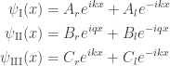

The continuity of the wave function and of its derivative yields four boundary conditions:

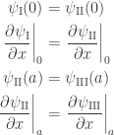

Plugging in the expressions for the wave functions \psi we get:

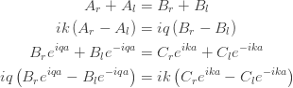

This is the system of equations we need to solve. However, this represents a very general case.

Let us consider a particle moving in from the left with a unit amplitude A_r \equiv 1. We will neglect the case of a particle moving towards the barrier from the right by setting C_l \equiv 0. We now rename the parameter A_l \equiv r, as it represents the reflected amplitude, and C_r \equiv t, since this corresponds to the transmitted part. We now have:

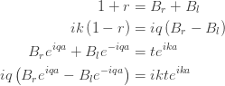

Four equations, four parameters. We can get rid of B_r and B_l, and find the expressions for the reflected and transmitted amplitudes. Their squares, |r|^2 and |t|^2, give us the reflection and transmission coefficients, respectively.

Let’s start by eliminating the parameters B_r and B_l. We can isolate B_r in the first equation (1):

1 + r = B_r + B_l \quad \Rightarrow \quad B_r = (1 + r) - B_l

We then plug this into the second equation (2):

i k \left(1 - r\right) = iq\left[(1 + r) - B_l - B_l\right]

i k \left(1 - r\right) = iq\left(1 + r - 2B_l\right)

i k \left(1 - r\right) - iq\left(1 + r\right) = -2iqB_l

B_l = - \dfrac{k}{2q} \left(1 - r\right) + \dfrac{1}{2}\left(1 + r\right)

We can now use this to find B_r:

B_r \equiv (1 + r) - B_l = 1 + r + \dfrac{k}{2q} \left(1 - r\right) - \dfrac{1}{2}\left(1 + r\right)

B_r = \dfrac{k}{2q} \left(1 - r\right) + \dfrac{1}{2}\left(1 + r\right)

Fortunately, some terms on the right cancel out, and solving for t we find:

t = \dfrac{4kqe^{i(q - k) a}}{(q + k)^2 - (q - k)^2 e^{2 i q a}}

# TUNNELING PROBABILITY

The probability that the particle tunnels through the barrier is equal to the modulus squared of the transmission coefficient T \equiv |t|^2. First, let us note that we care about the solution for a particle of energy E lower than the potential barrier height V_0. In such a case, we have that:

k = \sqrt{\dfrac{2mE}{\hbar^2}}\quad\text{and}\quad q = \sqrt{\dfrac{2m(E - V_0)}{\hbar^2}} = i \sqrt{\dfrac{2m(V_0 - E)}{\hbar^2}} \equiv iq'

Let us, therefore, replace q in the expression for the transmission coefficient t with iq' as seen above. And then, for the sake of convenience, we will relabel q' with q, keeping in mind that q is now a real number:

t = \dfrac{4ikqe^{-i k a}e^{-q a}}{(k + iq)^2 - (iq - k)^2 e^{-2q a}}

The tunneling probability is then calculated as:

T = \dfrac{4ikqe^{-i k a}e^{-q a}}{(k + iq)^2 - (iq - k)^2 e^{-2q a}}\cdot \dfrac{-4ikqe^{i k a}e^{q a}}{(k - iq)^2 - (-iq - k)^2 e^{-2q a}}

T = \dfrac{16k^2q^2e^{-2q a}}{\left[\left(k^2 + 2ikq - q^2\right) - \left(k^2 - 2ikq - q^2\right) e^{-2qa}\right]\cdot\left[\left(k^2 - 2ikq -q^2\right) - \left(k^2 + 2ikq - q^2\right) e^{-2q a}\right]}

We now use the fact that for any real a,\, b:\ (a + ib)\cdot(a - ib) = a^2 + b^2 to find:

T = \dfrac{16k^2q^2e^{-2q a}}{\left(k^2 - q^2\right)^2\left(1 - e^{-2qa}\right)^2 + 4k^2q^2\left(1 + e^{-2qa}\right)^2}

In the denominator we can use the identities for hyperbolic cosines and sines, e^{x} + e^{-x}\equiv 2\cosh{x} and e^{x} - e^{-x}\equiv 2\sinh{x}, respectively:

T = \dfrac{16k^2q^2}{\left(k^2 - q^2\right)^2\,4\sinh^2(qa) + 4k^2q^2\,4\cosh^2(qa)}

T = \dfrac{16k^2q^2}{4\left(k^4 - 2k^2q^2 + q^4\right)\sinh^2(qa) + 16k^2q^2\cosh^2(qa)}

Rearranging the terms:

T = \dfrac{16k^2q^2}{4\left(k^4 + q^4\right)\sinh^2(qa) - 8k^2q^2\sinh^2(qa) + 16k^2q^2\cosh^2(qa)}

we can use the identity \cosh^2(x) - \sinh^2(x) \equiv 1 to rewrite the last term of the denominator:

T = \dfrac{16k^2q^2}{4\left(k^4 + q^4\right)\sinh^2(qa) - 8k^2q^2\sinh^2(qa) + 16k^2q^2\left[1 + \sinh^2(qa)\right]}

T = \dfrac{16k^2q^2}{4\left(k^4 + q^4\right)\sinh^2(qa) + 16k^2q^2 + 8k^2q^2\sinh^2(qa)}

we have that:

\dfrac{\left(k^2 + q^2\right)^2}{4k^2q^2} = \dfrac{\left[E + (V_0 - E)\right]^2}{4E(V_0 - E)} = \dfrac{V_0^2}{4E(V_0 - E)}

and hence:

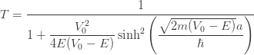

# PYTHON SIMULATION [(Code Link)](https://github.com/adityanjr/Sem-II/blob/master/QM_tunneling.ipynb)



Moreover, instead of having the wave function \psi(x, t) represent a plane wave solution, we will look at the time evolution of a localized Gaussian wave packet.

We start by importing several packages. In particular, we will require the sparse package to represent sparse matrices, and the sparse.linalg module to manipulate them.

Next, we create the Wave\_Packet class. It will require multiple parameters to instantiate.

We then carry on as follows:

1. Discretize space using a uniformly spaced grid x of step dx.
2. Initialize the wave function as a Gaussian packet. We first prepare a Gaussian distribution of deviation sigma0 centered at x0, which we then multiply by a complex exponential representing the initial momentum k0, and finally normalize:

\psi(x) = \frac{1}{\sqrt[4]{2 \pi \sigma^2}}e^{-\left(\frac{x - x_0}{2 \sigma}\right)^2} e^{i k_0 x}

1. Set up the potential as a zero array, except for the barrier which is located just to the right of the origin of the coordinate system.
2. Calculate the Hamiltonian matrix. Here we adopt the atomic unit system, in which the Hamiltonian assumes the simple form:

H = -\dfrac{1}{2}\Delta + V(x)

The action of the Laplace operator on a generic function f can be discretized according to the finite difference scheme:

\Delta f \approx \dfrac{f[x-\text{d}x] - 2f[x] + f[x + \text{d}x]}{\text{d}x^2}

In the script, we first create the arrays representing the diagonal and off-diagonal elements. Then, we use the sparse.diag() function to build a sparse matrix by specifying the diagonal elements and their respective distance from the main diagonal.

1. Finally, compute the time evolution operator. Given our differential equation:

H\psi(x, t) = i\dfrac{\partial \psi(x, t)}{\partial t}

we can discretize it in time as:

\dfrac{\psi(x, t + \text{d}t) -  \psi(x, t) }{\text{d}t}  \approx -i\,H\psi(x, t) 

This is called the forward Euler method, or the explicit method, as we can easily express the value of the desired function at the next time step from its value at the current step.

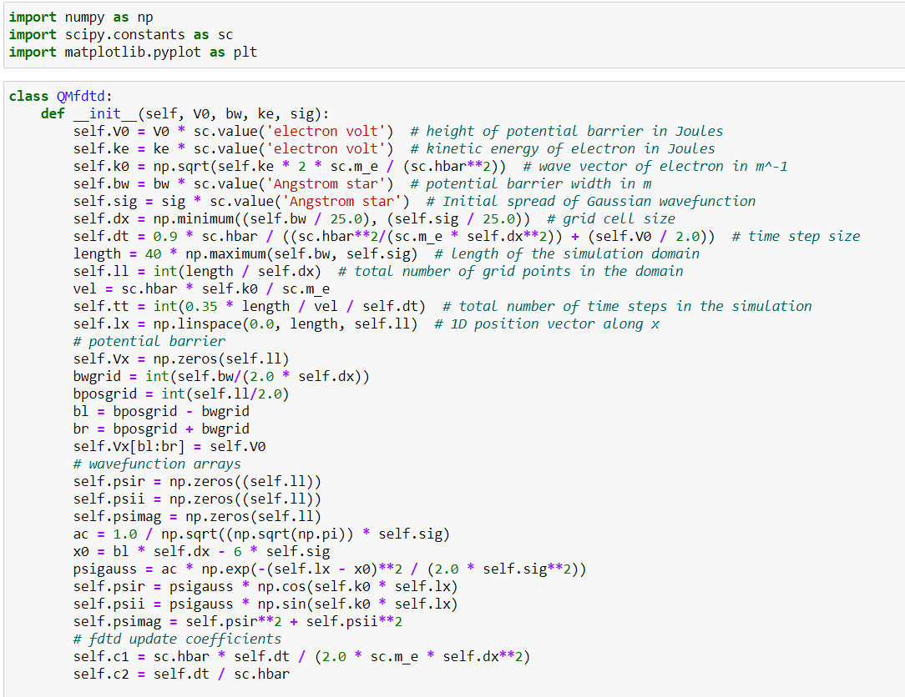

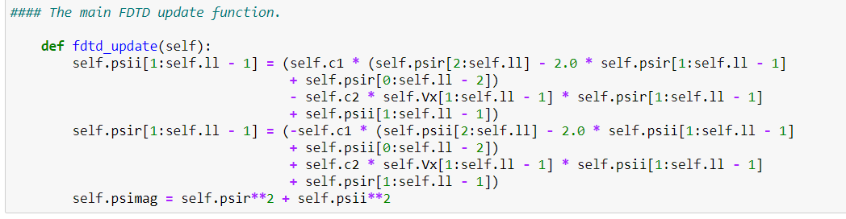

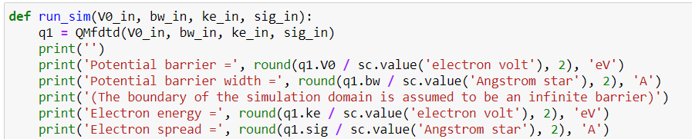

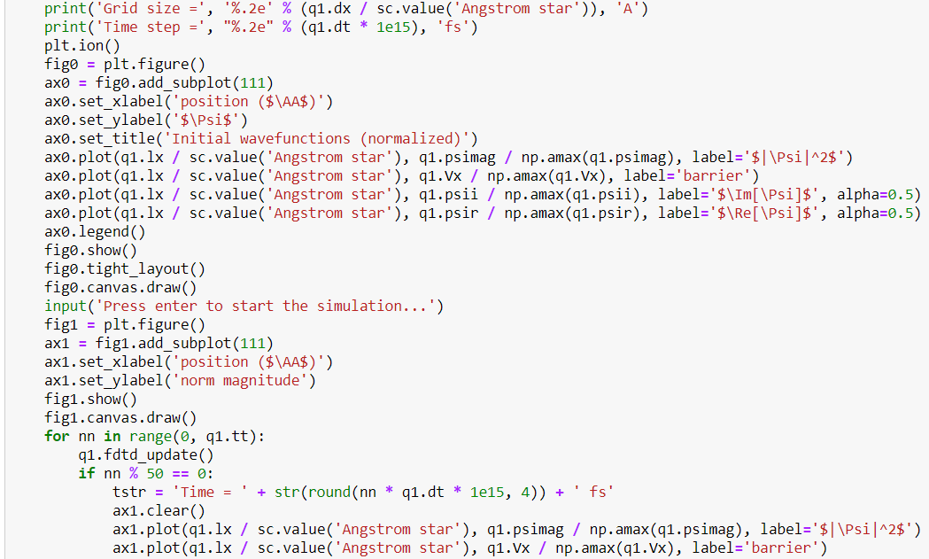

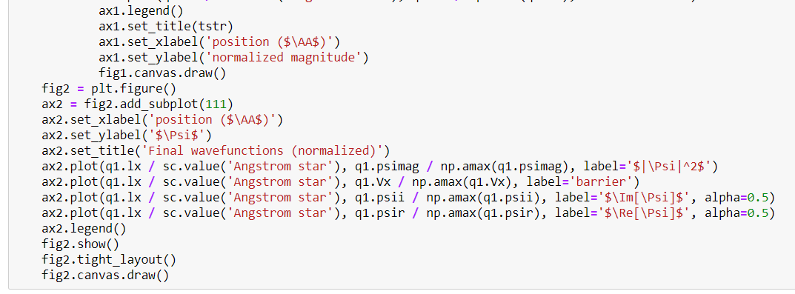

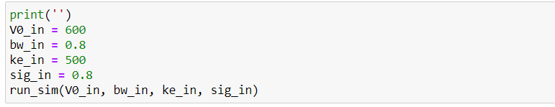

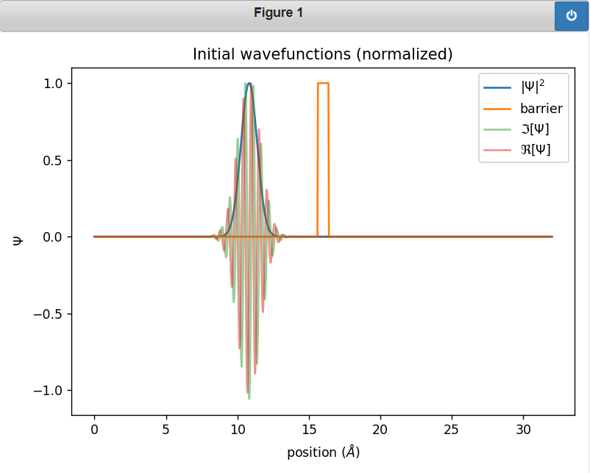

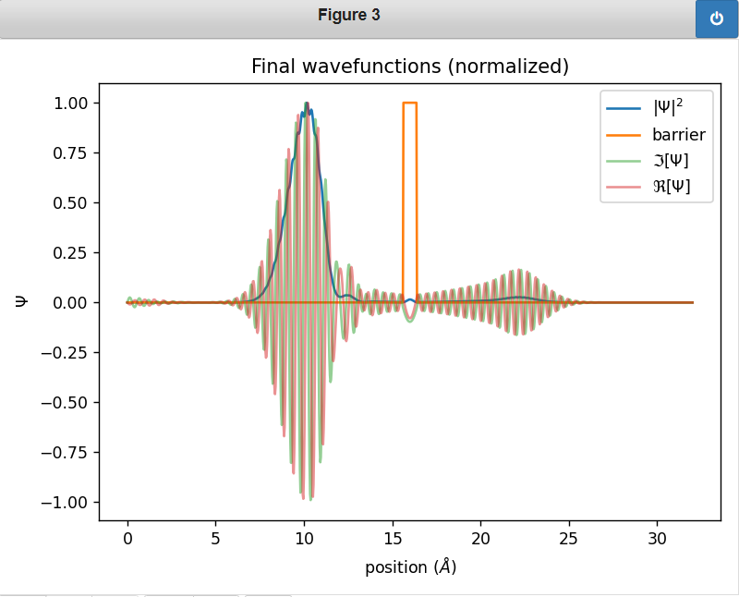

**THANK YOU**